ASSIGNMENT 1

TEAM ID: PNT2022TMID04331

Diagram 1:

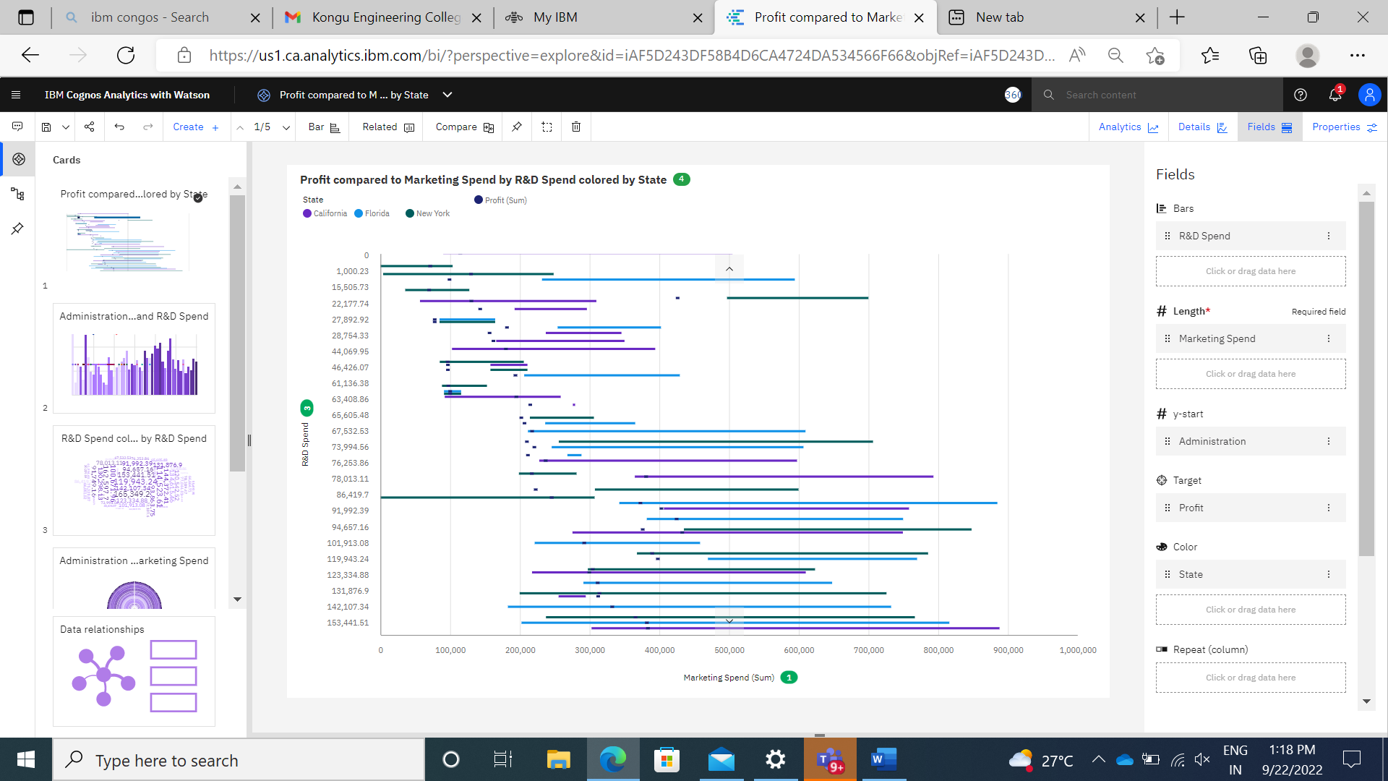

<https://us1.ca.analytics.ibm.com/bi/?perspective=explore&pathRef=.my_folders%2FStartups%2FProfit%2Bcompared%2Bto%2BMarketing%2BSpend%2Bby%2BR%2526D%2BSpend%2Bcolored%2Bby%2BState&subView=model000001836400c4a6_00000000>

Diagram 2:

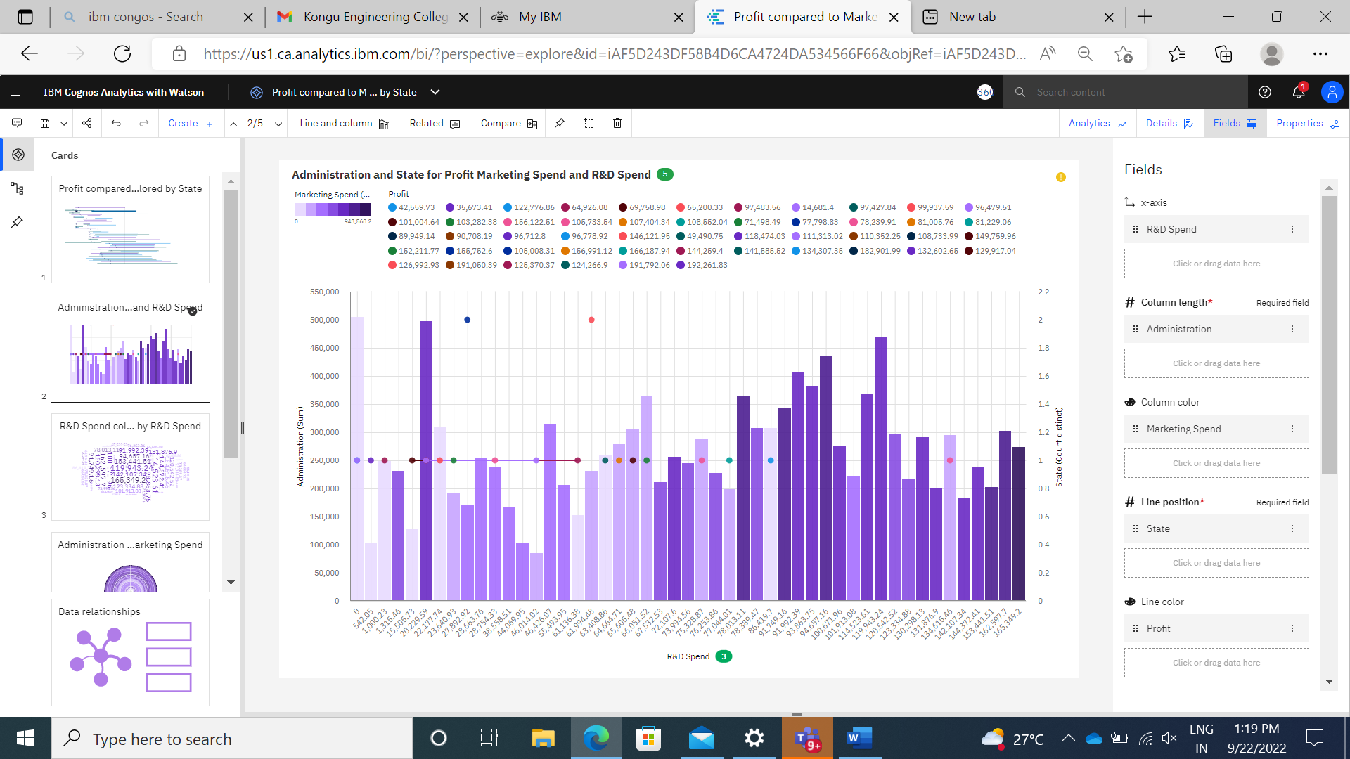

<https://us1.ca.analytics.ibm.com/bi/?perspective=explore&pathRef=.my_folders%2FStartups%2FProfit%2Bcompared%2Bto%2BMarketing%2BSpend%2Bby%2BR%2526D%2BSpend%2Bcolored%2Bby%2BState&subView=model00000183640b4b5d_00000003>

Diagram 3:

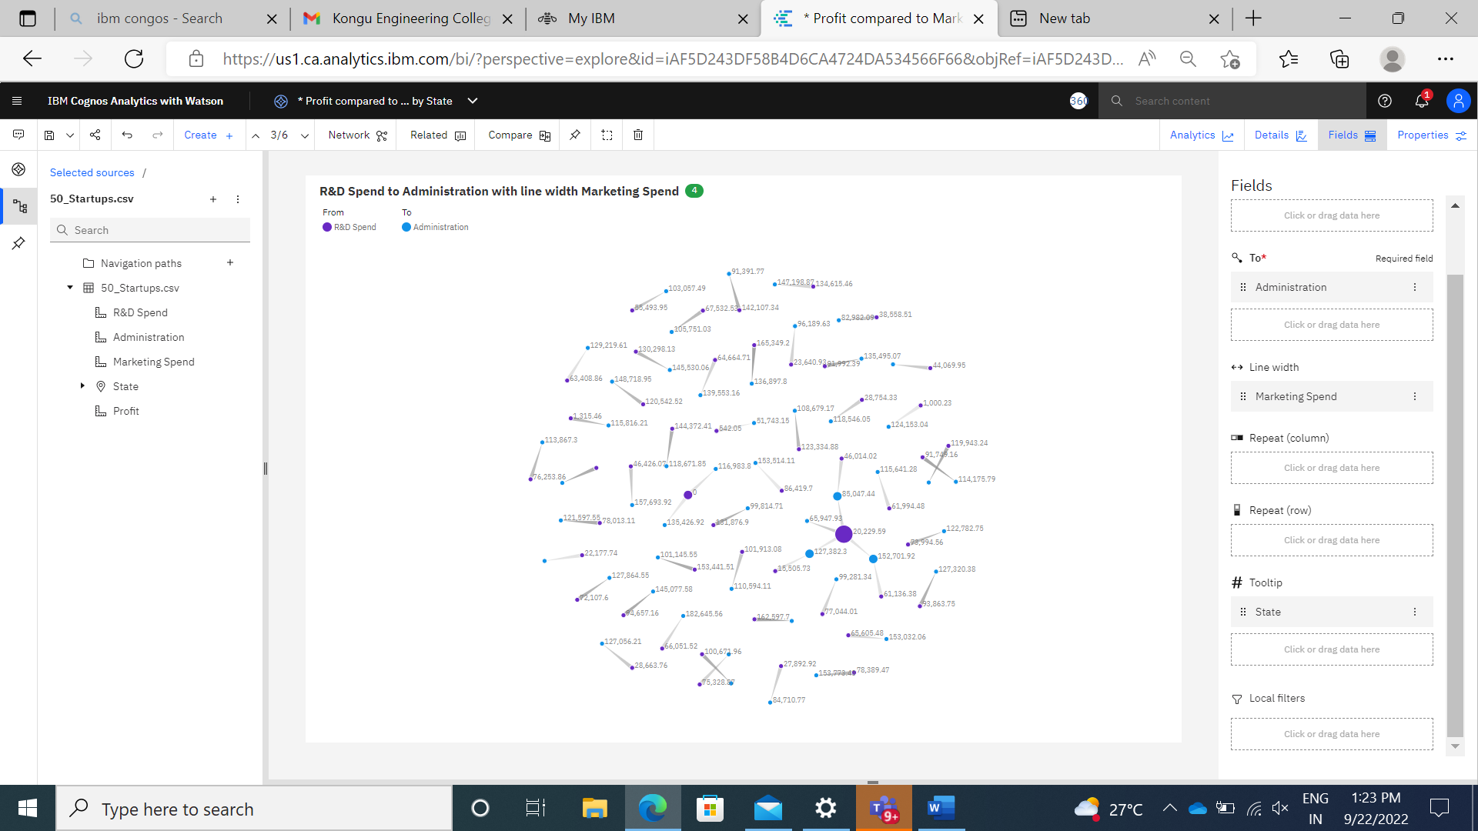

<https://us1.ca.analytics.ibm.com/bi/?perspective=explore&pathRef=.my_folders%2FStartups%2FProfit%2Bcompared%2Bto%2BMarketing%2BSpend%2Bby%2BR%2526D%2BSpend%2Bcolored%2Bby%2BState&subView=model00000183642de1fa_00000003>

Diagram 4:

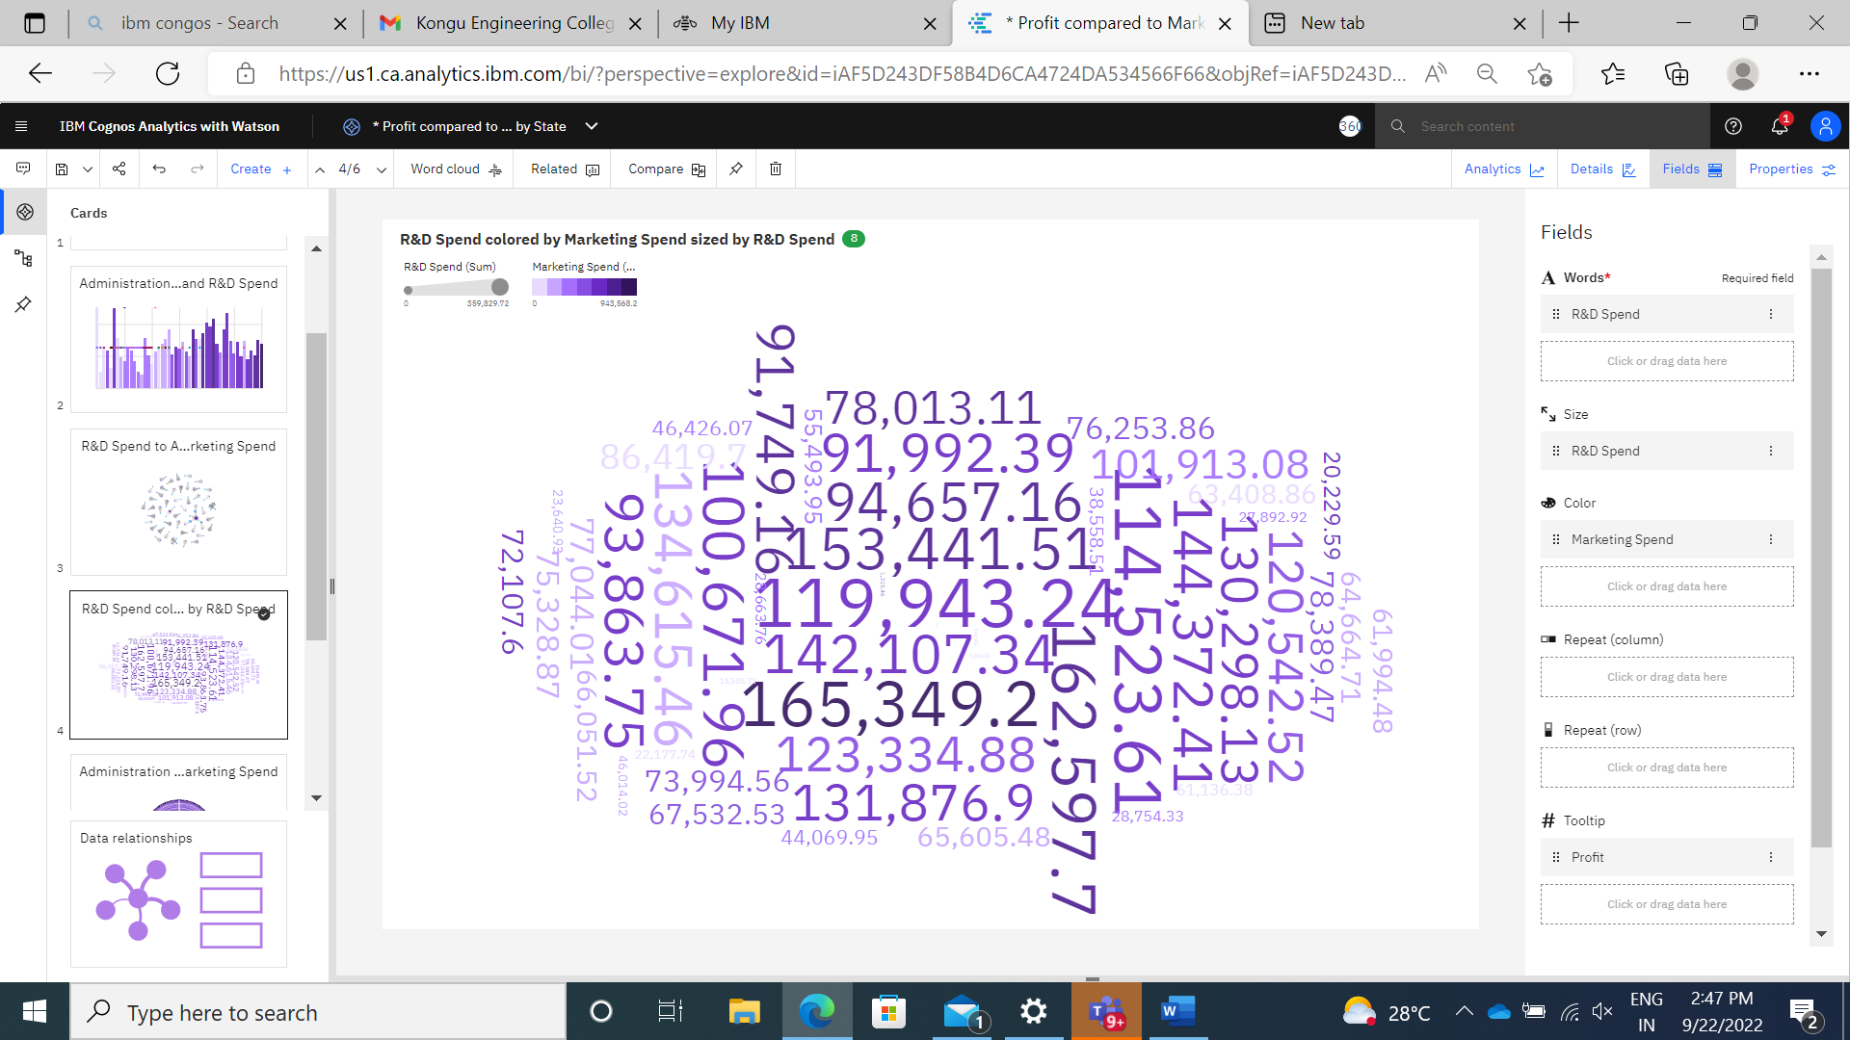

<https://us1.ca.analytics.ibm.com/bi/?perspective=explore&pathRef=.my_folders%2FStartups%2FProfit%2Bcompared%2Bto%2BMarketing%2BSpend%2Bby%2BR%2526D%2BSpend%2Bcolored%2Bby%2BState&subView=model00000183641654b5_00000002>

Diagram 5:

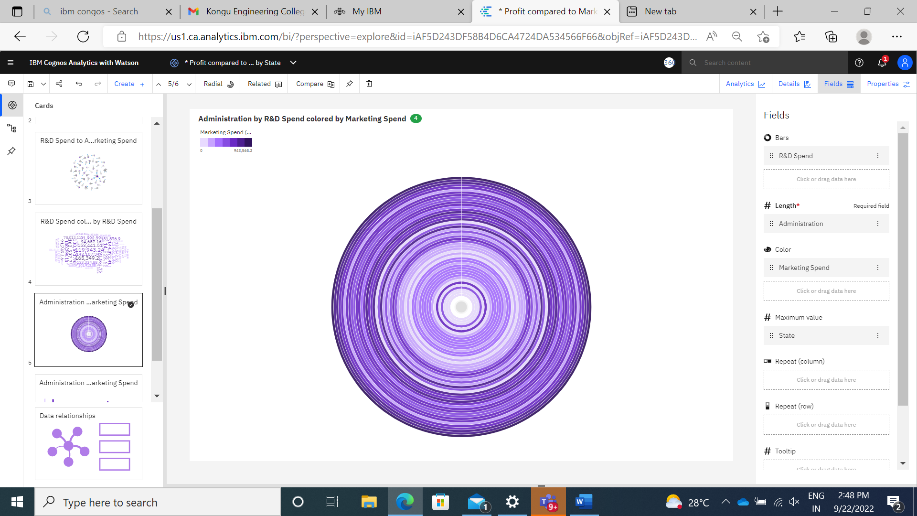

<https://us1.ca.analytics.ibm.com/bi/?perspective=explore&pathRef=.my_folders%2FStartups%2FProfit%2Bcompared%2Bto%2BMarketing%2BSpend%2Bby%2BR%2526D%2BSpend%2Bcolored%2Bby%2BState&subView=model000001836418f055_00000000>

Diagram 6:

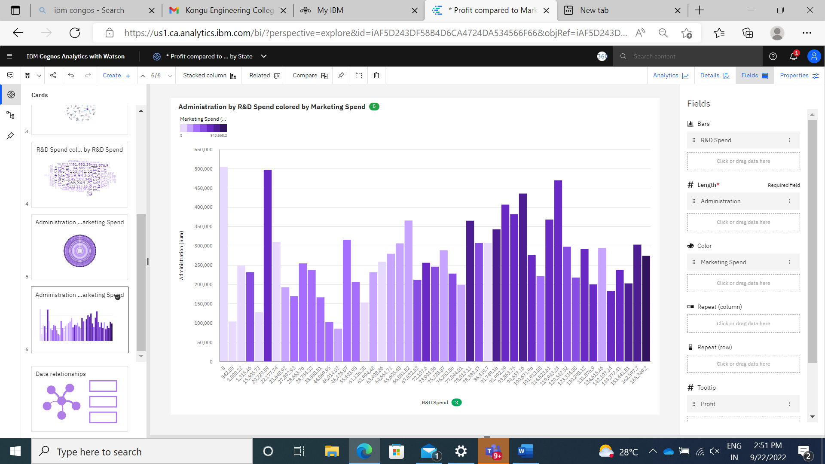

<https://us1.ca.analytics.ibm.com/bi/?perspective=explore&pathRef=.my_folders%2FStartups%2FProfit%2Bcompared%2Bto%2BMarketing%2BSpend%2Bby%2BR%2526D%2BSpend%2Bcolored%2Bby%2BState&subView=model000001836419bd81_00000000>